Bilkent University

Department of Computer Engineering

CS 319 - Object-Oriented Software Engineering

Final Report

**Man of War**

**Group 1-D**

* Berat Tuna Karlı
* Ceren Uysal
* Serdar Erkal
* Selim Fırat Yılmaz

Contents

1. How implementation went? 3

2. Are there any major changes to the design had to be made due to complications during the implementation? 4

2.1. Thread 4

2.2. Attack System 4

2.3. Credits 5

2.4. Health Bar information 5

2.5. Wall effects 5

2.6. Change difficulty 5

2.7. Info Panel 5

2.8. Change direction keys 5

2.9. Different Bullet Colours 6

2.10. Mob Movement and Fire 6

2.11. Sounds 6

3. User’s Guide 7

3.1. How to open the game 7

3.2. Tutorial for the game 8

4. The status of the implementation 17

5. References 18

6. Exposed Documentation of the software system (Appendix) 19

7. Appendix 20

# How implementation went?

The implementation process was easier than we have expected. Since we have prepared very detailed and useful analysis and design reports. As we have learned in the lectures, we have tried to use forward engineering which requires first planning detailed and comprehensive analysis and design reports then implementing the code Therefore, we have made use of the diagrams such as the class diagram, the sequence diagrams, use case diagrams and so forth during the implementation process. We have some difficulties during the implementation. The integration and the execution of the code was kind of hard, because we sometimes have implemented our codes independently. While integrating the newly added codes we have errors which are caused by case sensitivity (Upper-lower letters, conflict between ı-i).

# Are there any major changes to the design had to be made due to complications during the implementation?

We observed that there are some changes required in the game, therefore we made several major changes in order to handle and improve the implementation. Also some changes are made on game play to have a better game logic in order to appeal players more.

Changes are listed below;

## Thread

The movement of the main character with the help of Thread and the conversion of items into the rectangles. We have used Threads in order to update the whole system by providing graphical smoothness of the game. We represented bounding boxes of the objects via rectangle in order to resolve collusions easily.

## Attack System

In order to have a new and improved attack system, we decided not to use quick time event based attack system. Instead of this, we changed the system to more dynamic and smooth one. The reason why not using QTE based attack system is that the flow of event had caused some delays and it could have created some errors related to attack system. The new attack system supports mobs, bosses and the main character to attack with the help of bullets instead of attacking when character has only encountered with enemy.

The bullet system is implemented due to the new attack system. The bullet has its own power and velocity. Also character class has updated, bullet class has been imported to Character class.

## Credits

This part is located on the main frame and it includes several information about the project and contributors of the project.

## Health Bar information

Health bar is displayed above the character. This bar includes information about the health of the character. This bar moves with the character in order to have more dynamic view for players.

## Wall effects

At some points in the game, we added squeezers on the walls which are opening and closing in a specified time period to make the levels harder and make the game more appealing to players.

## Change difficulty

In the previous iteration, we have planned to change the difficulty of the level after pressing the “Play the Game” Button. But in the current implementation, we change the difficulty of the level in settings. We have 3 options (Easy, Normal, Hard) for the game.

## Info Panel

We have added info panel to main game frame. This panel includes information about the purpose of the game, how to play the game and several general information about the game.

## Change direction keys

We have changed the direction keys in order to provide some flexibility to player. The default setting for direction keys are set to the arrow keys.

## Different Bullet Colours

We have provide 2 different bullet colours for mobs. Hence, there are two different types of mobs, we have decided 2 different coloured bullets for 2 different mobs.

## Mob Movement and Fire

In the previous iteration mobs were not able to move or fire, we have decide to change this to make mobs more dynamic and hard to defeat. This features make the game more challenging and interesting. To make these changes, we had to change the images of mobs and bosses. They are taken from Metal Slug [1].

## Sounds

In the previous version we only had opening sound of the game, we wanted to make the game more entertaining so that we have changed the opening sound to “Damaged Coda”[2] and also added several different sounds for different events of the game such as defeating, level-up, power-up, game over, background sound from the “freesound.org”[3] and so forth.

# User’s Guide

## 3.1. How to open the game

The process of opening the game is very easy. If the player downloads the game, jar file is located inside the bin folder, player should clicks on it directly and starts playing the game.

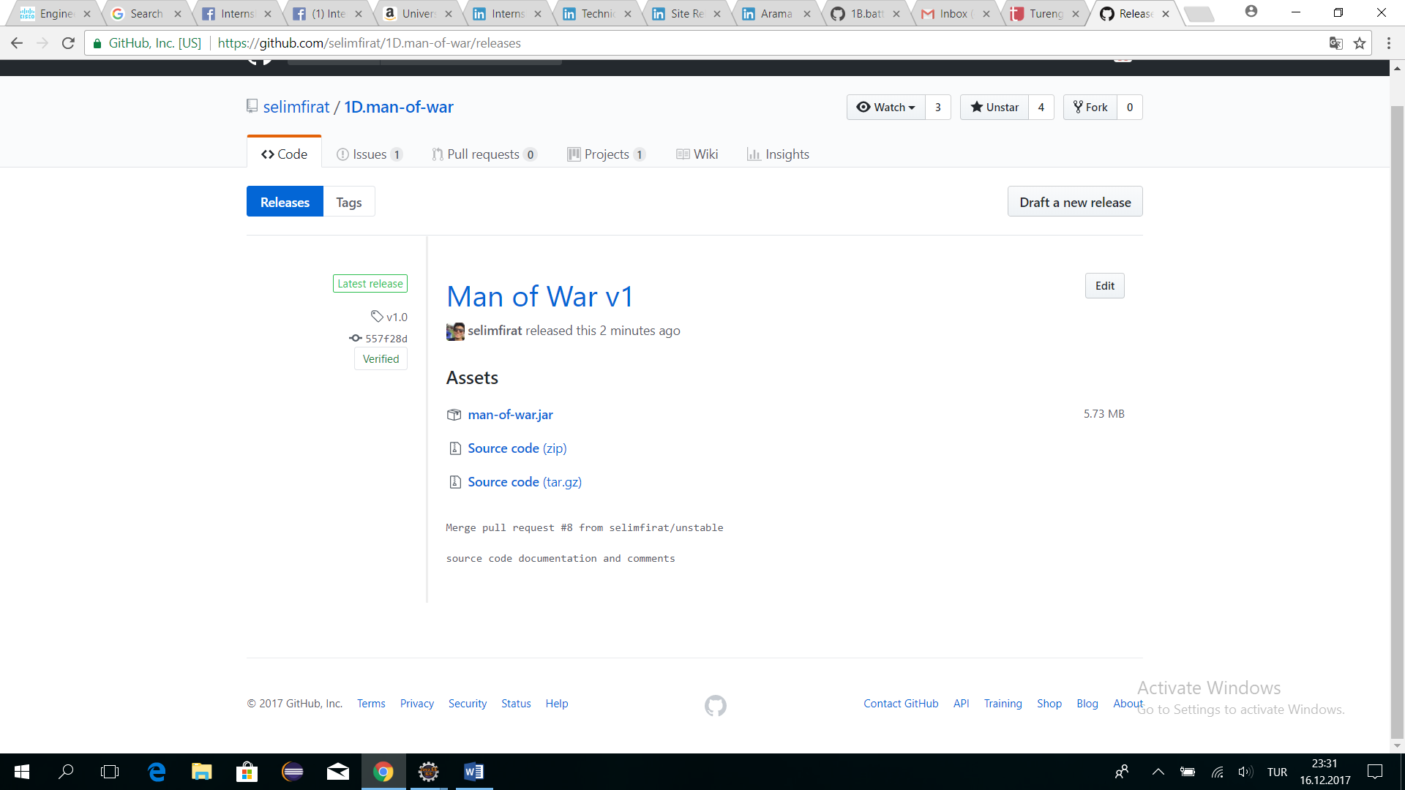

First go to github repository of 1D.man-of-war, click on the releases button at the left top button. Then click on [**man-of-war.jar**](https://github.com/selimfirat/1D.man-of-war/releases/download/v1.0/man-of-war.jar), this will download the game directly. After downloading the jar file, click on it and start playing the game.

## 3.2. Tutorial for the game

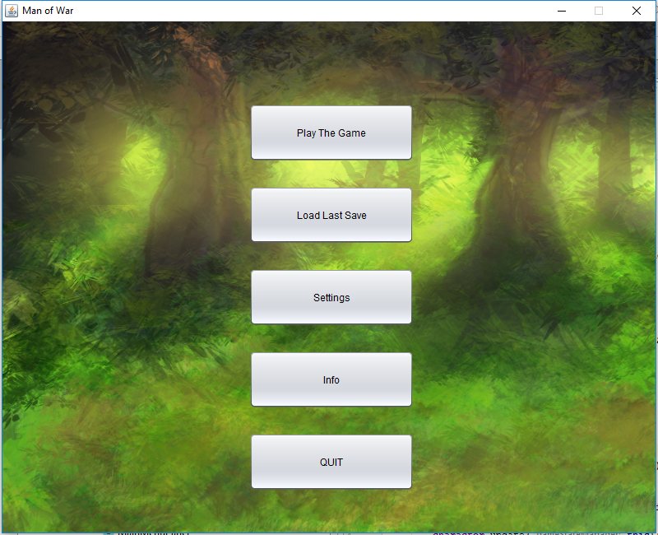

There is a main menu which includes 5 sections. These 5 sections are Play The Game, Load Last Save, Settings, Info, Quit. If the player wants to play the game (s)he should click on the Play Game button.

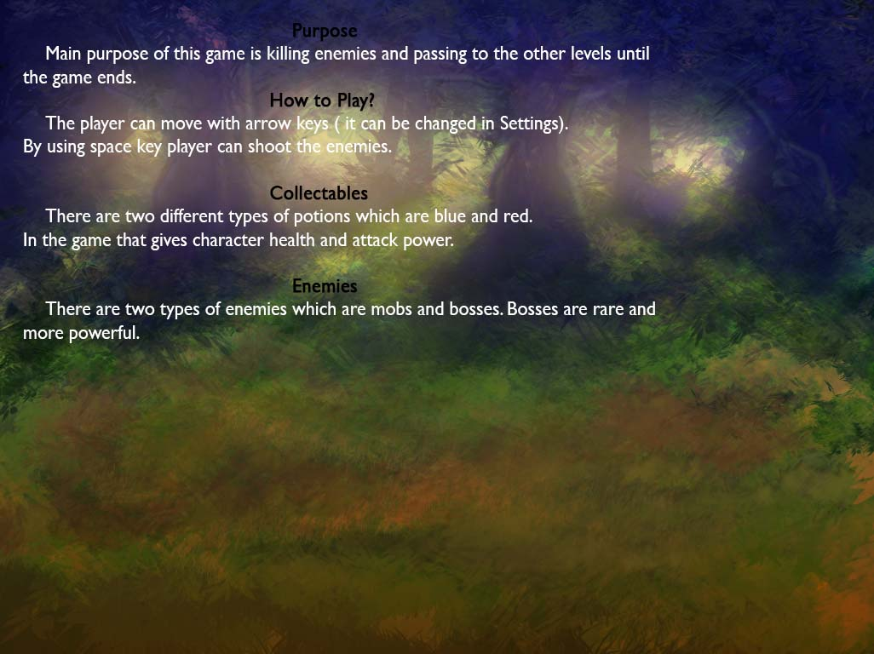

(Info Screen)

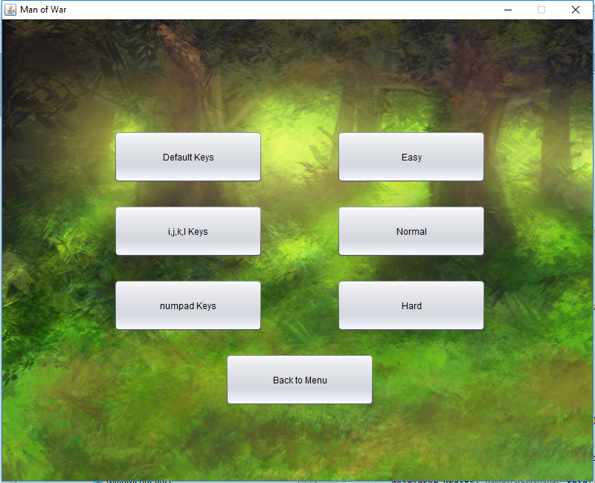

(Settings Screen)

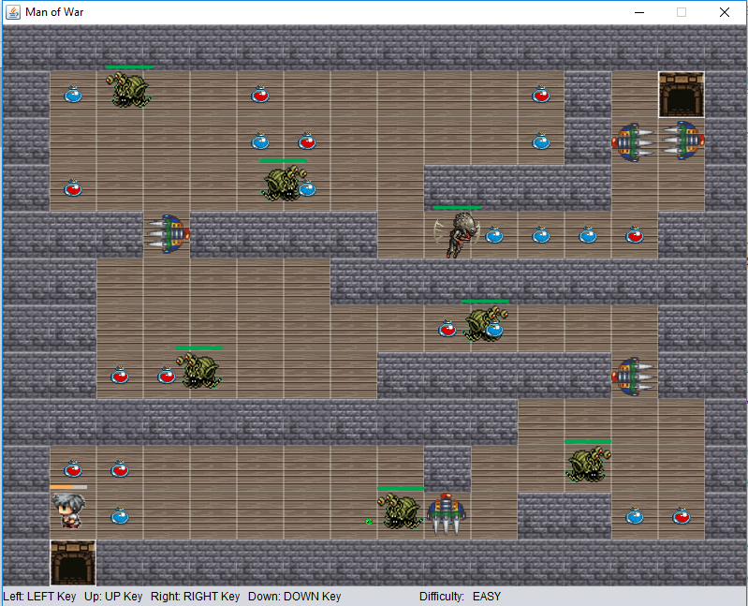

(Level 1)

After clicking “Play the Game”, the game map is uploaded and the player directly starts the game from the first level. There are mobs to fight and defeat in order to reach the gate and pass to the next level.

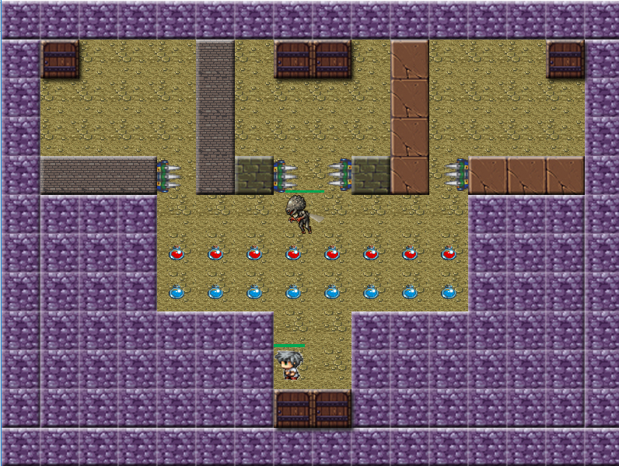

(Level 2)

Different gates are opening to different levels. Two of the doors is responsible for tricking the player, one is opening to the past level and one is opening to the same level. Last gate is sending player to the right (next) level.

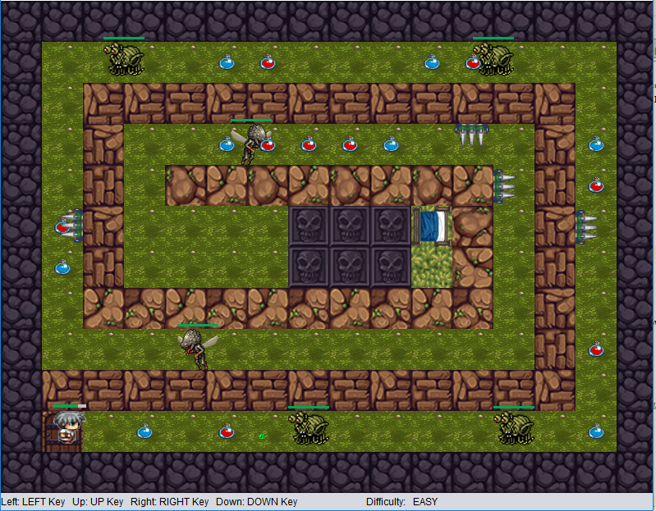

(Level 3)

The character moves with the help of key arrows (four directions: left, right, up, down). With respect to the player preference, the direction keys could be changed in the settings. When the character encounters with a mob, the mob starts to fire.

The purpose in this level is reaching the bed (next to skulls) to sleep a while.

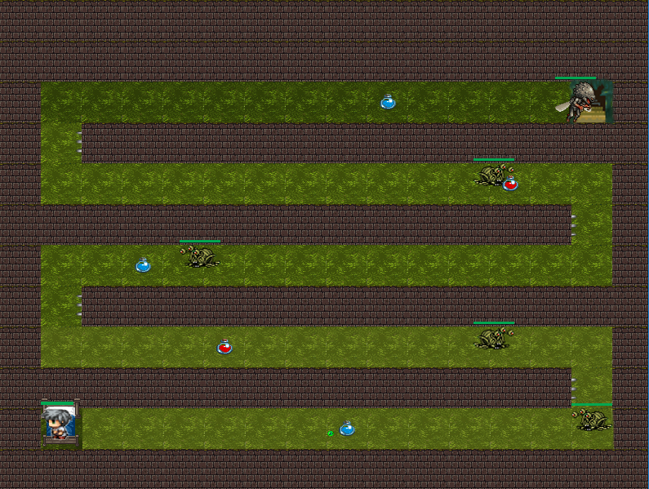

(Level 4)

There will be red and blue potions to be collected. Both the red and blue potions increase the health of the character and only the blue potion increase the attack power of the character.

This level starts after the character took a nap. Now he awakens and hits the road again.

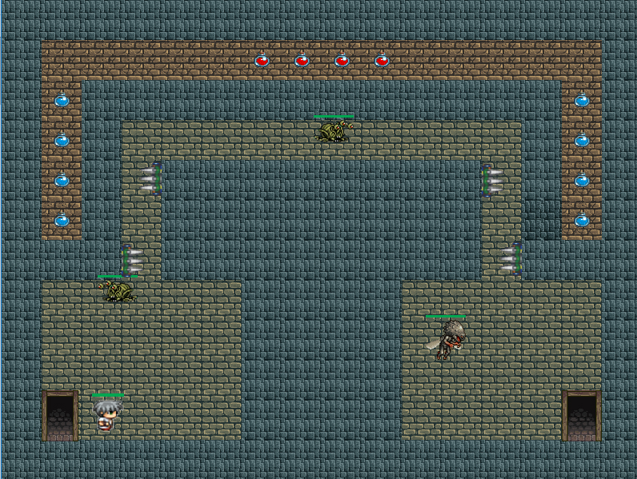

(Level 5)

There are several squeezer machines moving forward and backward in a specified time period to trap the character and decrease his health.

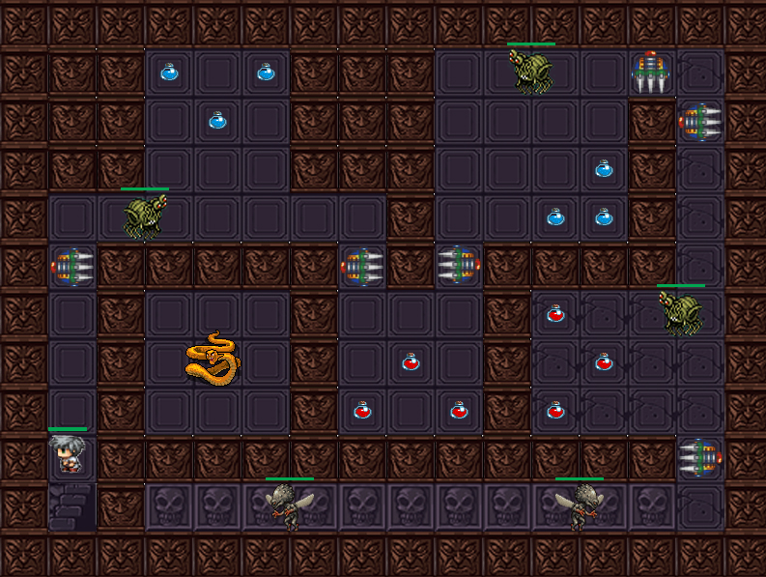

(Level 6)

Level 6 is the last and the hardest level of the game. When the character reaches the lollipop (at the end of the skulls), he is finally happy after a long pursuit of the precious lollipop. The aim of the game has totally accomplished.

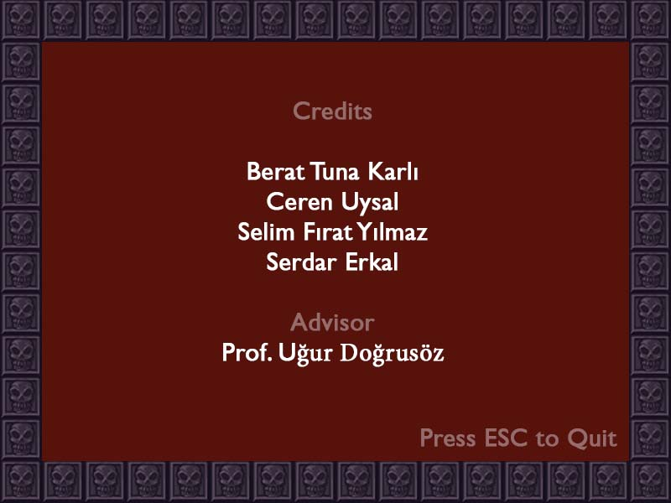

(Credits)

After the game is finished, the credits screen appears. This part could be seen from the main menu too.

# 4. The status of the implementation

There are some parts which are not implemented and some parts could not be integrated or implemented with some missing functionalities.

One of the unimplemented part is the full screen option. We have not implement this option since we would have serious problems with the graphics of the game.

Sound part is implemented and sound files are collected but the implementation part could not be integrated into the game.

# 5. References

[1] The images of the mobs and bosses are taken from metal slug.

<https://www.spriters-resource.com/arcade/ms6/>

[2] The entrance sound “Damaged Coda” in the main menu is taken from the song of “Blonde Redhead”.

<https://www.youtube.com/watch?v=4Js-XbNj6Tk>

[3] The remaining sounds of the game are taken from the site below.

<https://freesound.org/>

# 

# 6. Exposed Documentation of the software system (Appendix)

The exposed documentation of the software system can be found in the **pdf file** in doc folder.

# 7. Appendix

The Javadoc for the exposed members of the software system can be accessed by the link below.

<https://selimfirat.github.io/1D.man-of-war-javadoc/>